Mohammed Shahnawaz Khan 23/07/2024 Linux Command Execution

1. Create user with name Techie and provide sudo access to user.
2. Navigate to the home directory.(pwd command)

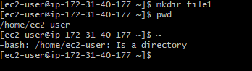

1. Create a new directory.(mkdir filename command)

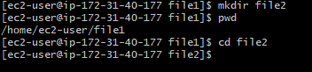

1. List the contents of a directory.(cat filename command)

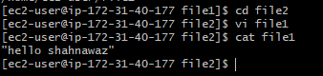

1. Change the current directory .(cd command)

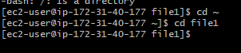

1. Create a new empty file.(touch command)

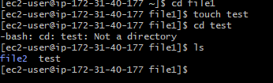

1. View the contents of a file.(vi filename and cat filename commands)

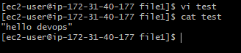

1. Copy a file to another location.(cp /tmp/ command)

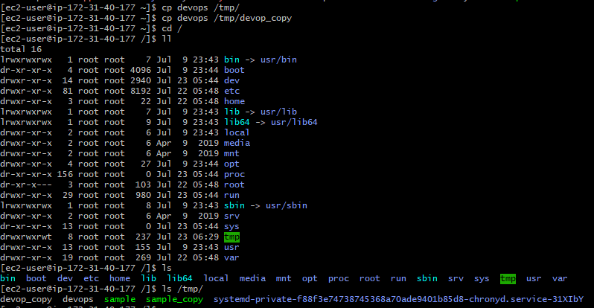

1. Rename a file (mv old filename new filename command).



1. Move a file Another Location.

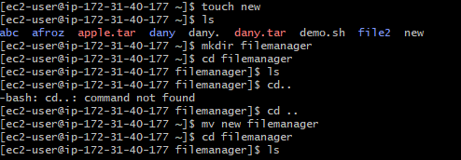

1. Delete a file (rm filename command)

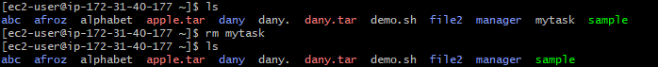

1. View the current date and time.

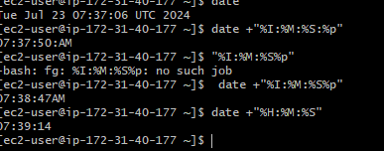

1. Check the system uptime.



1. View the running processes.

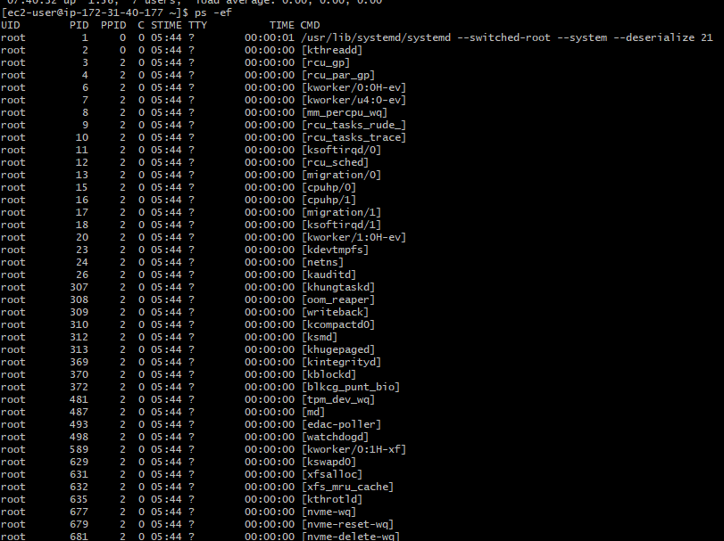

1. Kill a running process.

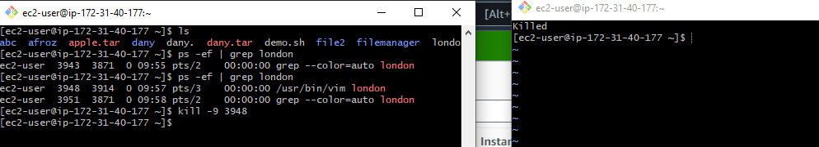

1. Update the system pakages.

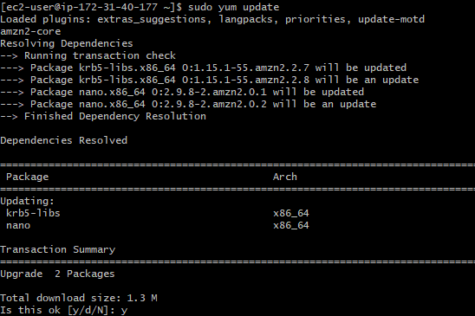

1. Create a symbolic link.

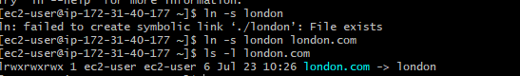

1. Search for files using the find command.

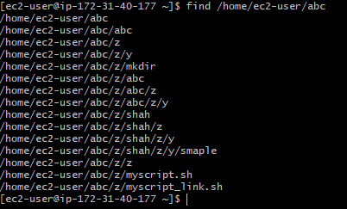

1. Compress and decompress files using tar.
2. Monitor system resources top and htop.

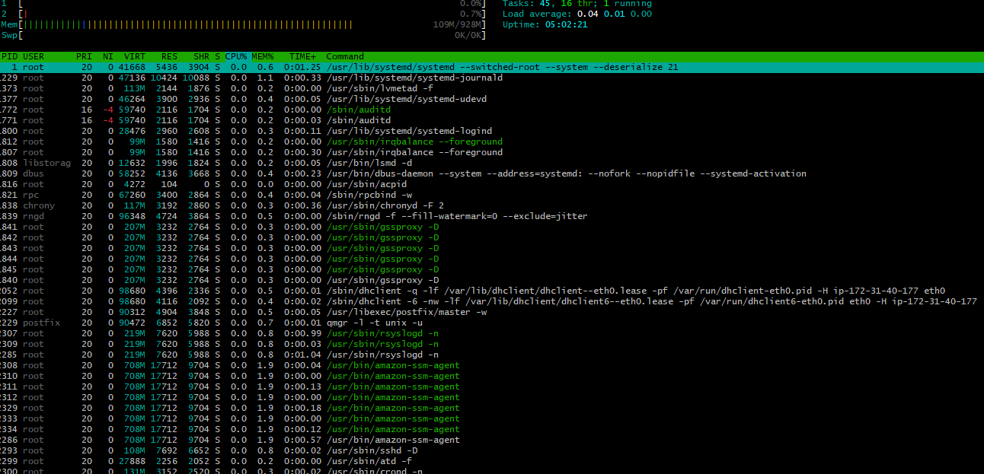

1. Create and manage user groups.

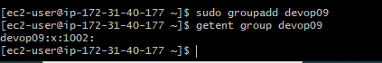

1. Monitor log files using tail or grep.

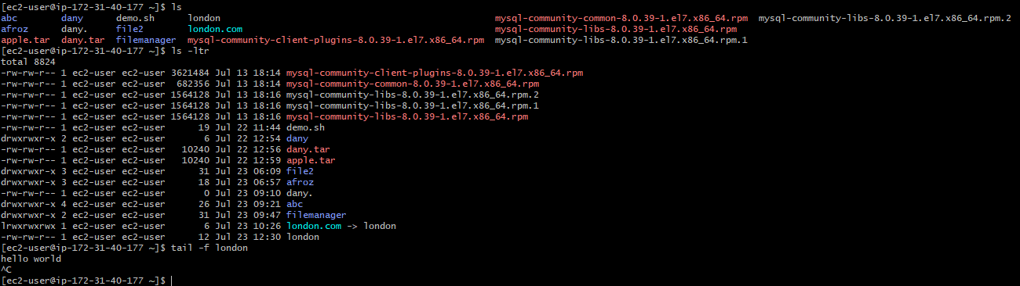

1. Configure and secure MYSQL Database.

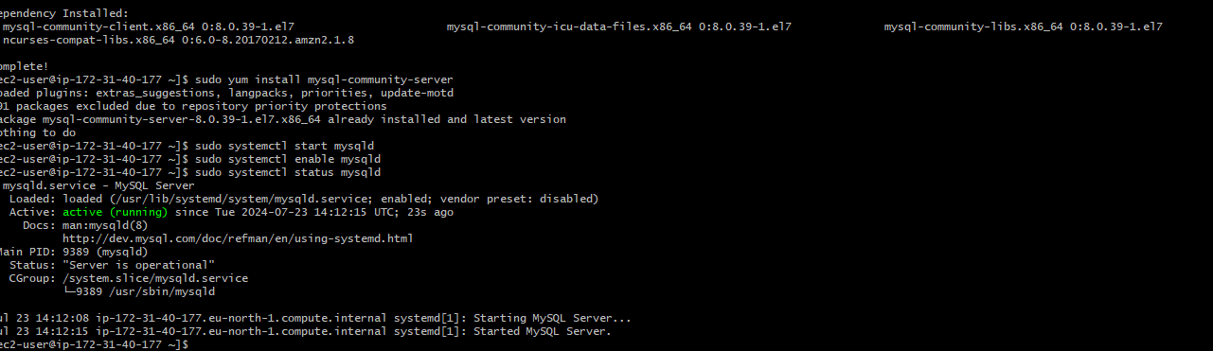

1. Set up a web server (e.g., Apache or Nginx).

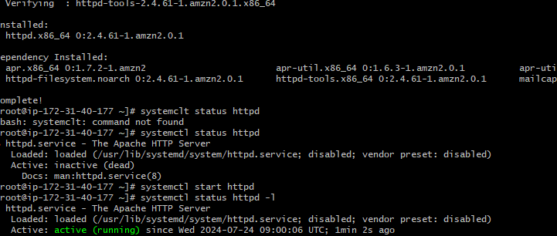

1. create a service file for Apache Tomcat.(Should execute by using systemtctl command)

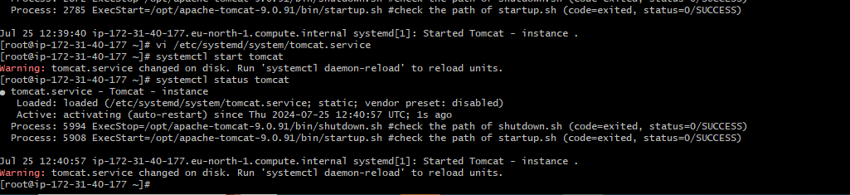

1. Print specific columns from a delimited file.